**MANU9M6 PROJECT MANAGEMENT ASSIGNMENT OCHILS' SKI CENTRE**

**REPORT**

1. **Schedule Analysis**

**Project network plan**

|  |  |  |  |  |  |  |  |  |  |  |  |  |
| --- | --- | --- | --- | --- | --- | --- | --- | --- | --- | --- | --- | --- |
| **Activities** | **A** | **B** | **C** | **D** | **E** | **F** | **G** | **H** | **I** | **J** | **K** | **L** |
| **Immediate predecessor** | **_** | **_** | **_** | **C,I,A** | **J** | **J** | **E** | **K,L** | **_** | **D** | **D** | **D** |
| **Time(weeks)** | **8** | **1** | **24** | **90** | **1,3** | **1** | **6** | **25** | **24** | **2** | **13** | **12** |

**Option 1.**

The figure below illustrate how various flow activities in ORC project in the first option. The Alphabets represents the actual activities of the project.

A-Project Approval G-Lift inspection

B-Construction Staff training H-Marketing Campaign

C-land purchase and planning approval I-Design

D-Construction plan J-Health and safety inspection

E-Final staff training K-Material preparation

F-Opening of OSC business L- Agreement establishment with UK

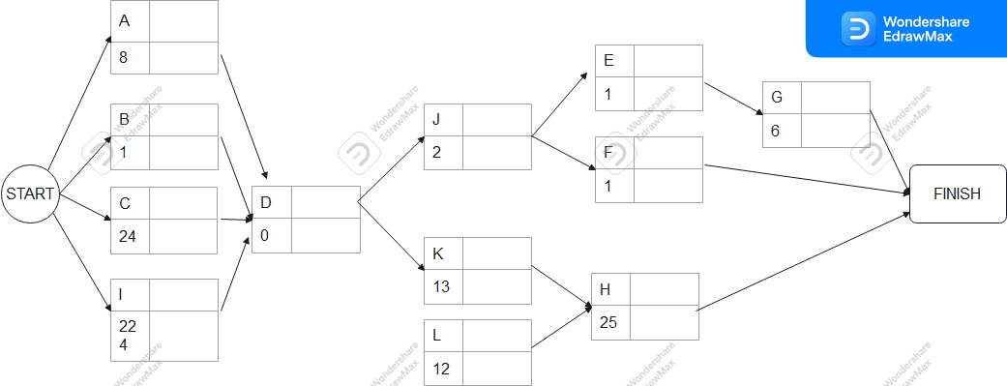

The diagram show the flow of event from start to Finish. Arrows indicates the direction of flow of events.

**Second option**

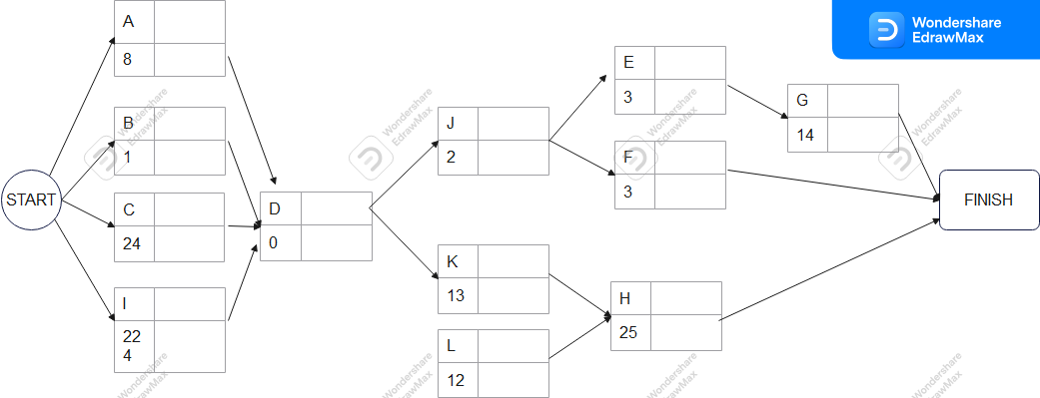

Resource constraint is one of powerful metrics that is used in design and construction of project network plan.

Time Constraints are used in the construction of the project networks shown above.

**2.1 Financial Appraisal**

Financial appraisal of project consider the potential rewards of carrying out the project against predicted costs. The evaluation depends on the size of the project and the time span over which the cost and benefits are going to spread.

The return payback is analyzed in number of ways in order to determine the net benefit. Some of this methods includes Payback analysis, Discount cash flow and internal rate return.

In my project I will evaluate some of the subsection of the two options given in the project.

To begin with the market NPV is as shown below;



The best cause of action is choosing the option with high NPV value, in our case the option with largest NPV value is option2 with £528925.62

Based on financial appraisal in the FInancial Apprisal.xls file show that the option is option 2 bacause it has high profits compared to option 1.

**Assumed data**

**Option1**

|  |  |  |
| --- | --- | --- |
| **Income** |  |  |
| **Restaurant** | **income per year** |  |
| Airthrey | 170000 |  |
| Lossburn | 520000 |  |
| Balquharm | 8900000 |  |
| 7-Ski-lifts | 800000 |  |
| Ski-shop | 910000 |  |
| **Total income** | **11300000** |  |
| **operting cost** | **900000** |  |
| **Profits** | 10400000 |  |
|  |  |  |

**option 2**

|  |  |
| --- | --- |
| **Income** |  |
| **Restaurant** | **income per year** |
| Airthrey | 2500000 |
| Lossburn | 6500000 |
| Balquharm | 7500000 |
| 7-Ski-lifts | 8000000 |
| Ski-shop | 900000 |
| **Total income** | **25400000** |
| **operting cost** | **2400000** |
| **Profits** | 23000000 |
|  |  |

**Sensitivity Analysis & use of historical data**

Through use of linear regression tool, it has been made possible to estimate the costs and number of weeks needed for construction of given length based on the collected experience from some other similar sites, The linear equation on each graph will help to predict the number of weeks and costs of construction of ski-lifts.

Fig 2

Fig 3

A project is financial viable if the economic benefits the project exceeds its economic costs when analyzed for society as a whole. The economic cost of the project are not the same as its financial costs externalities and environment impact should be considered.